Weather page - Kyle Ondecker

The weather page adds simplicity to something that is widely used and available all over. This weather page just uses the geolocation with permission from the user to provide the weather for the day and a 5 day forecast. It also provides some weather for global cities. The rules followed include consistency as all of the pages have a similar navigation bar for control over the website and each section of weather follows a similar layout and color scheme. Another rule followed is to reduce short term memory load as the user only has a small amount of information available to them. The 5 day forecast allows them to easily recognize the trends where a 7 day forecast may be too much to look at and have to remember. Also there are only a few global cities provided for reference and the local weather is a main focus as that is usually what is most important. Also another rule followed is internal locus of control, because the webpage requests access to the geolocation before pulling up local weather. This allows the user to be in control of what the webpage displays, and if they don’t want the location to be known then it won’t pull the information and be visible. Easy reversal of actions is also implemented as the navigation bar allows users to navigate back to the other pages easily. No secure design principles were followed for this page other than requesting permission to access location. No other secure information is requested or known by just using the weather page.

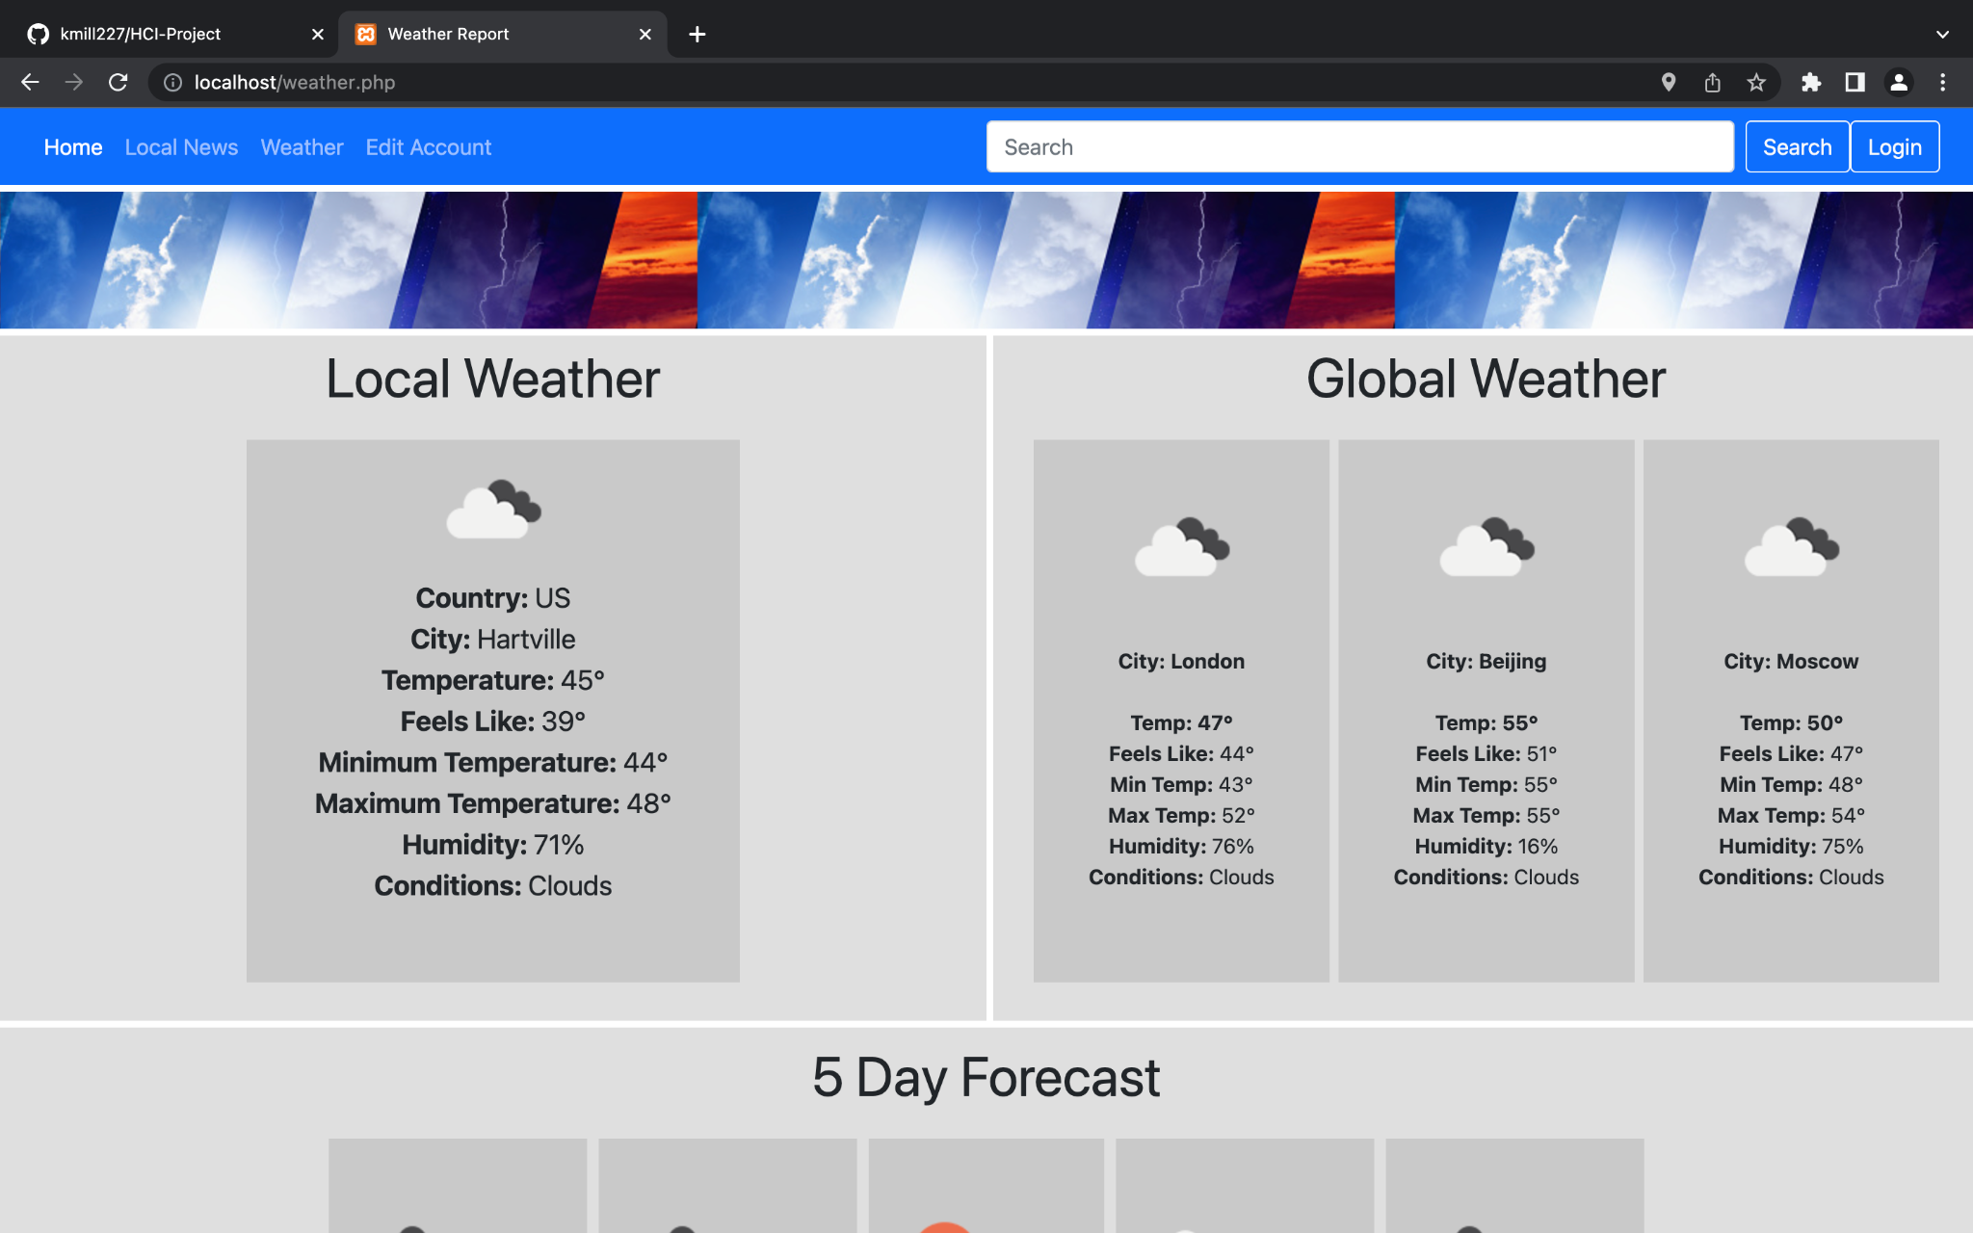

Global News - Robin Oster

The global news page, as the name implies, provides news coverage on breaking news stories all around the world. Rules followed for this webpage include consistency, as all elements of the web page follow a consistent blue and white color scheme, and the menu bar used for navigation is the same across all pages of the website. Informative feedback is another guideline followed by this page, though more so as a feature of css than a conscious decision: links change colors when clicked and hovered over. Short-term memory load is reduced by only displaying 7 stories on a page at once, in an effort not to overwhelm the user with information. The user is required to use the search feature to search for more stories if they so wish.

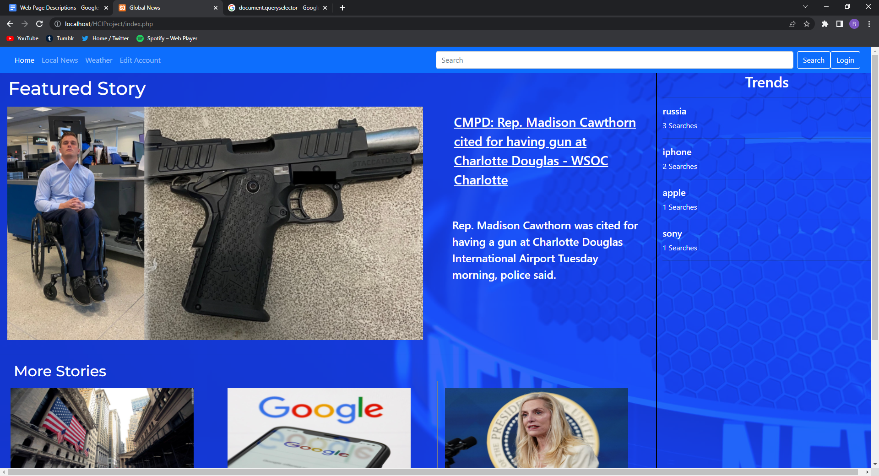

Local News - Kaleb Miller:

The local news page gets the users location via geolocation, converts it to a city and state string then displays up to 12 articles that mention both the city and state and up to 12 more articles that mention only the state. The rules I used were consistency, supporting the internal locus of control, reducing short term memory load, easy reversal of actions, and informative feedback. Consistency was used on my page because all articles are displayed in a card format with even spacing between cards, and similarly sized images that are cropped if need be instead of stretched. All elements on the page also follow the same theme which is just white cards on a white background with an image and a title. It is also consistent with other pages by maintaining the navigation bar from page to page. I supported the internal locus of control by giving the user choices of which articles that they want to click on to read more about rather than displaying text from the articles. This also works to reduce the memory load as it cleans up the page and doesn’t overload the user with information. Easy reversal of actions is implemented through the navigation bar because if someone ends up on the page by mistake, they can easily return to one of the other pages. I used informative feedback by changing the color of the link when it is hovered over to let the user know that when they click they will be redirected to a different page as is typical of how hyperlinks are implemented across the internet.

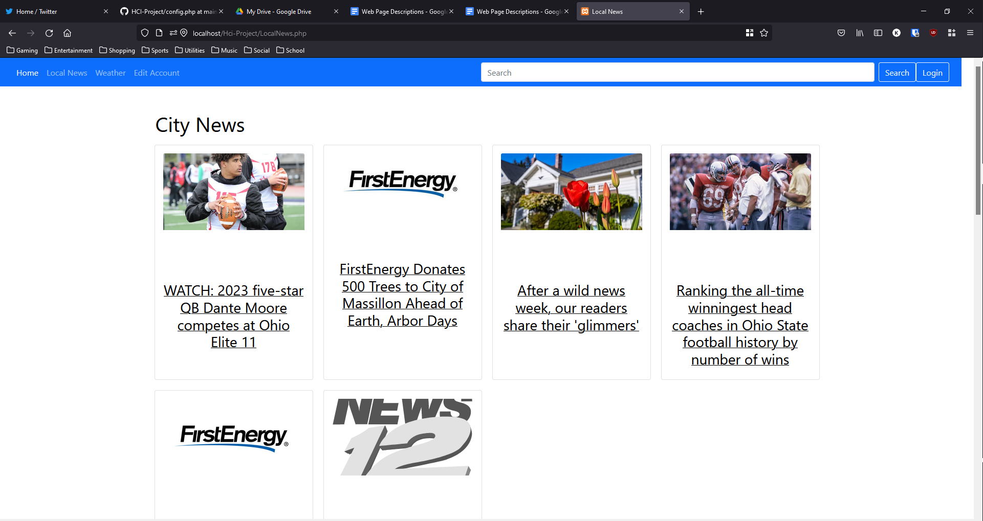

Sign In/Sign Up - Steven Danko:

The sign in/sign up page allows the user to to create a personal account that can store user metadata such as search history, geolocation data and other preferences. The authentication process uses the Auth0 api, ensuring the password is hashed on the user’s side and all personal information is transmitted with tsl and stored encrypted on an external server. The sign in page is themed blue and white consistently with the other pages, internally font types input/button size and interaction are all the same supporting Shneiderman’s rule for consistency. The page defaults to the sign in process and hides the sign up form, this is to reduce memory load and increase usability for regular users. Error prevention and feedback are two areas that I had to make compromises in, the sign up process will report errors in the creation of a new account, a user name already in use and a password longer than 15 characters with a JavaScript alert, but I decided against adding an error message for the sign in process as I felt an error message reporting an incorrect email address or password could open up the site for user analysis.

